SONARQUBE – SAST IMPLEMENTATION
NexGuard-SecureFlow
Static Application Security Testing and Jenkins Integration
Project Documentation

Technology: SonarQube + Jenkins
Purpose: Static code quality and security analysis

1. Introduction
SonarQube is a static code analysis platform used to continuously inspect source code for bugs, vulnerabilities, security hotspots, code smells, code duplication, and other maintainability issues. In the NexGuard-SecureFlow project, SonarQube was integrated with Jenkins so that code quality and security analysis could be performed as part of the CI/CD pipeline.

2. Objective
- Integrate SonarQube with Jenkins for automated static code analysis.
- Analyze application source code for quality and security issues.
- Define a Quality Gate to establish minimum quality and security requirements.
- Validate the analysis result through the Jenkins pipeline.

3. SonarQube–Jenkins Integration
A SonarQube authentication token was generated and configured in Jenkins as a credential. This allows Jenkins to communicate with the SonarQube server without exposing the token directly in the pipeline configuration.
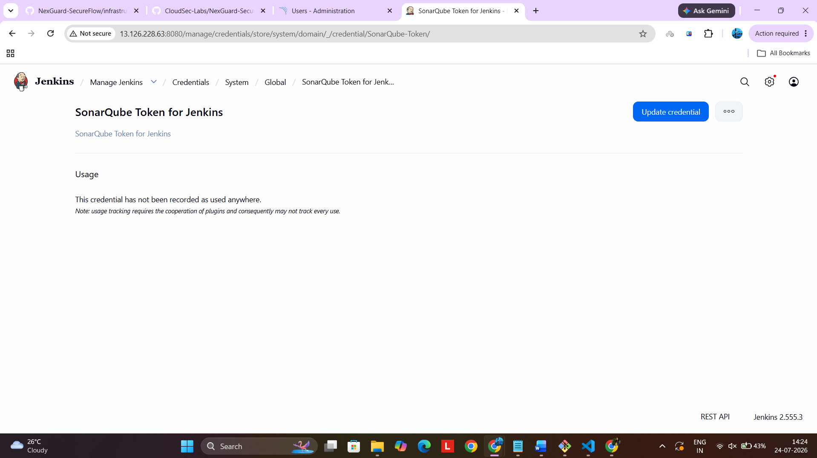
Figure 1: SonarQube credential configured in Jenkins
The Jenkins credential is referenced by the pipeline during SonarQube analysis. The actual secret value is not displayed in the documentation.

4. SonarQube Webhook Integration
A webhook was configured in SonarQube to send the Quality Gate analysis result back to Jenkins after the SonarQube analysis is completed. This enables Jenkins to receive the Quality Gate status and continue the pipeline based on the analysis result.
The webhook is an important part of the SonarQube–Jenkins integration because it allows Jenkins to receive the result asynchronously instead of repeatedly checking SonarQube for the status.
Typical flow: Jenkins starts the SonarQube analysis -> SonarQube analyzes the code -> SonarQube evaluates the Quality Gate -> webhook sends the result to Jenkins -> Jenkins continues the pipeline.

4. Quality Gate Configuration
A Quality Gate defines the conditions that analyzed code must satisfy before it is considered acceptable. The configured SonarQube Quality Gate checks important metrics such as code coverage, duplication, reliability, maintainability, and security.
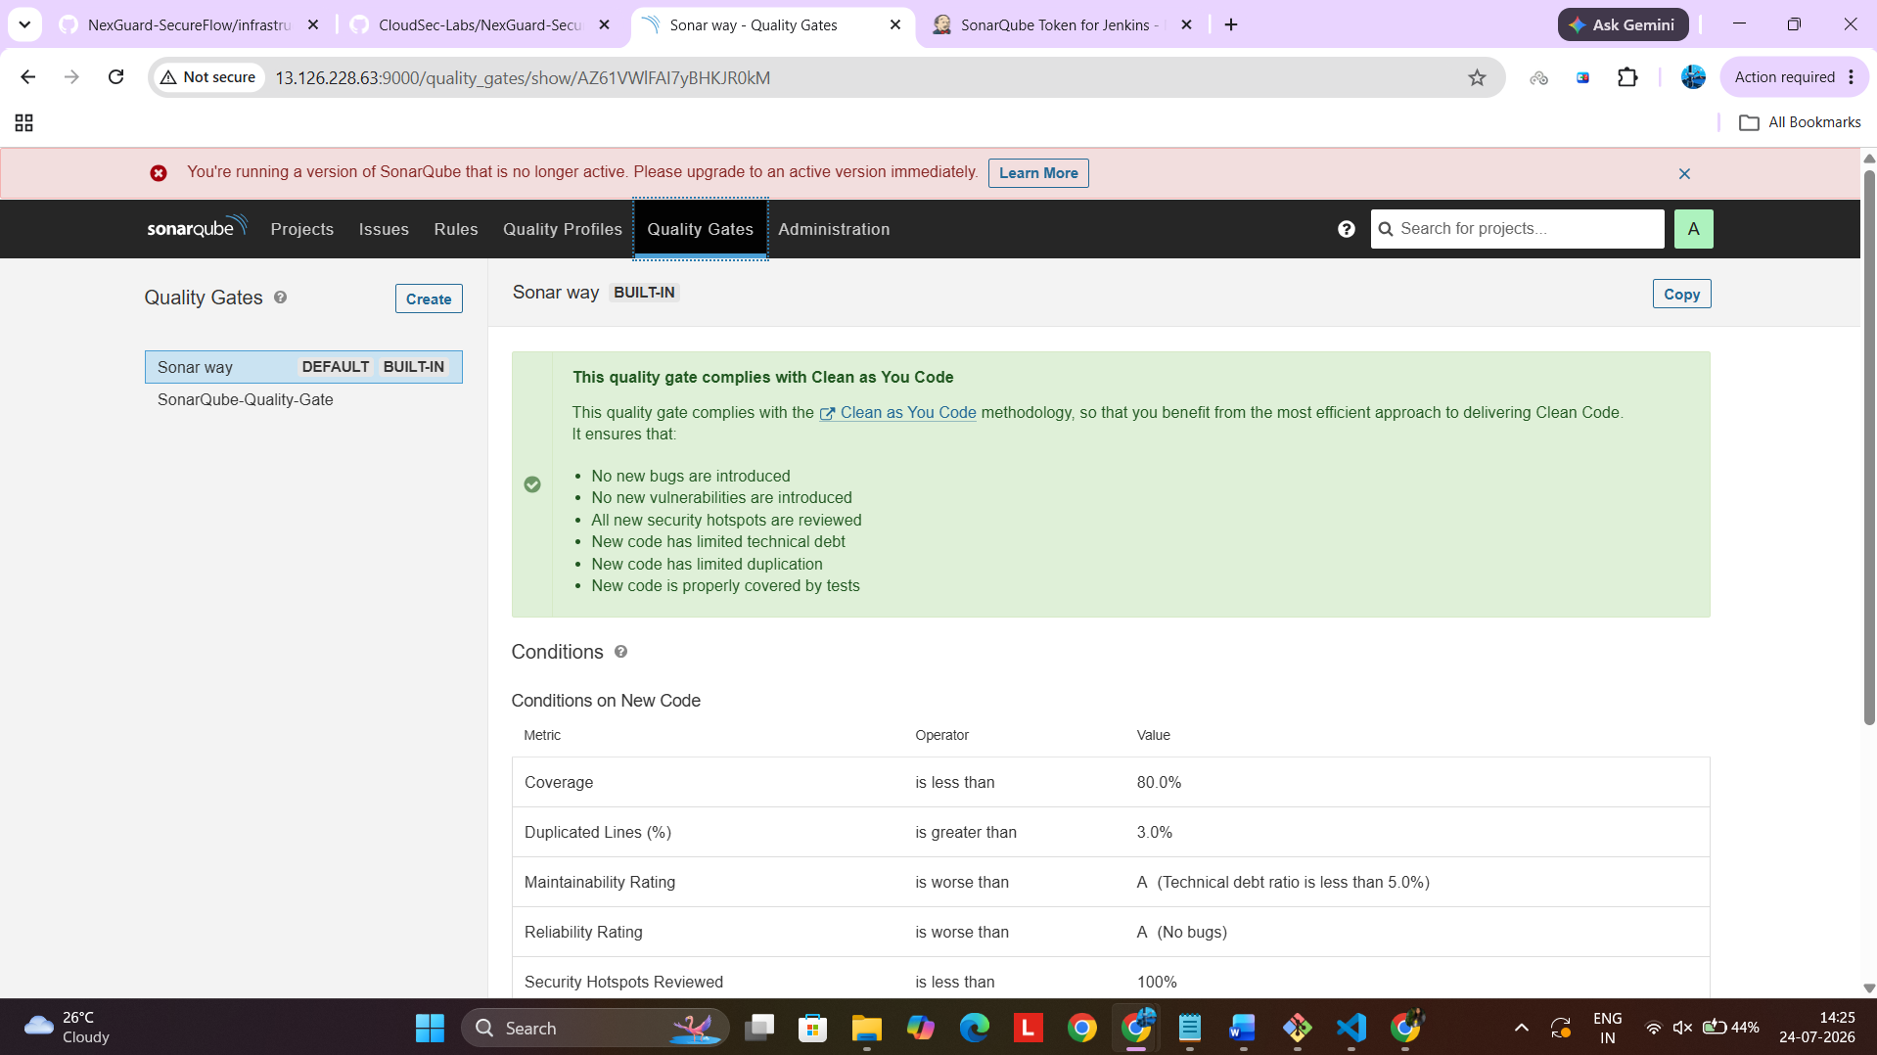
Figure 3: SonarQube Quality Gate configuration
The Quality Gate includes conditions such as minimum code coverage, maximum duplicated lines, acceptable maintainability and reliability ratings, and security requirements. These checks help prevent code with unacceptable quality or security characteristics from being treated as production-ready.

5. SonarQube Code Analysis
The NexGuard-SecureFlow project was analyzed by SonarQube. During the implementation, an initial analysis did not satisfy the configured Quality Gate. The result is shown below.
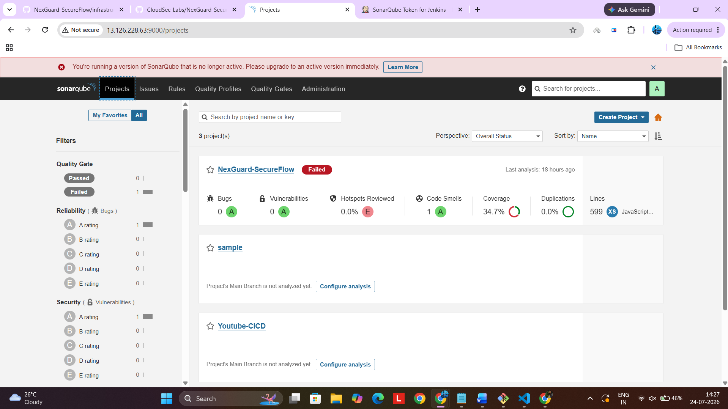
Figure 4: Initial SonarQube analysis showing Quality Gate failure
The initial result showed that the Quality Gate was not satisfied, primarily because the project did not meet the configured coverage requirement. This provided a useful validation that the Quality Gate was actively evaluating the project.

7. Final Quality Gate Validation
After further changes and re-analysis, the NexGuard-SecureFlow project successfully passed the Quality Gate. The final analysis reported zero bugs and zero vulnerabilities, 100% security hotspots reviewed, 0% duplication, and an improved coverage value.
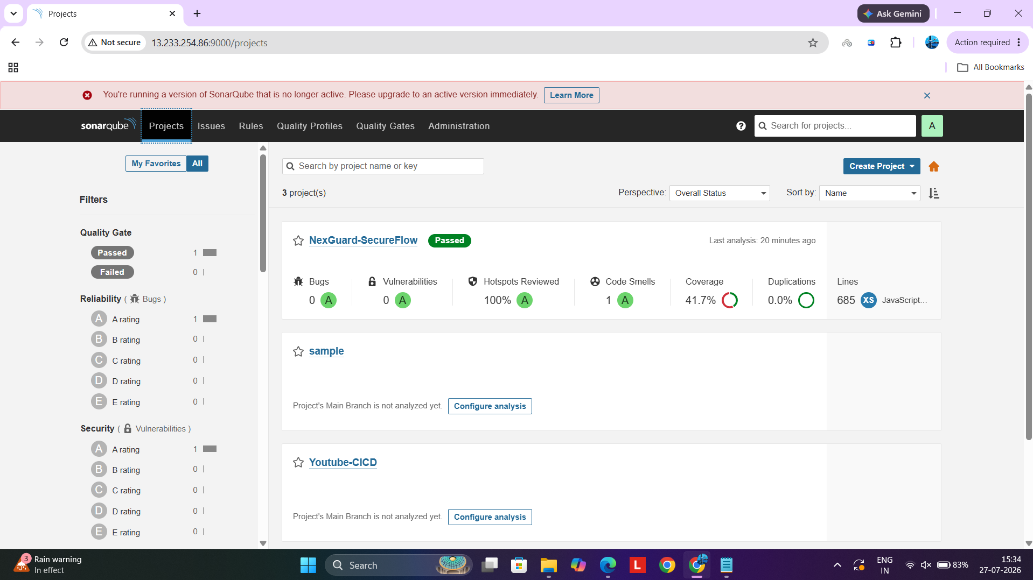
Figure 5: NexGuard-SecureFlow successfully passing the Quality Gate

8. Final Result
The final SonarQube analysis confirmed that the project passed the configured Quality Gate. The analysis provided visibility into code quality and security metrics and demonstrated that SonarQube was successfully integrated into the development workflow.
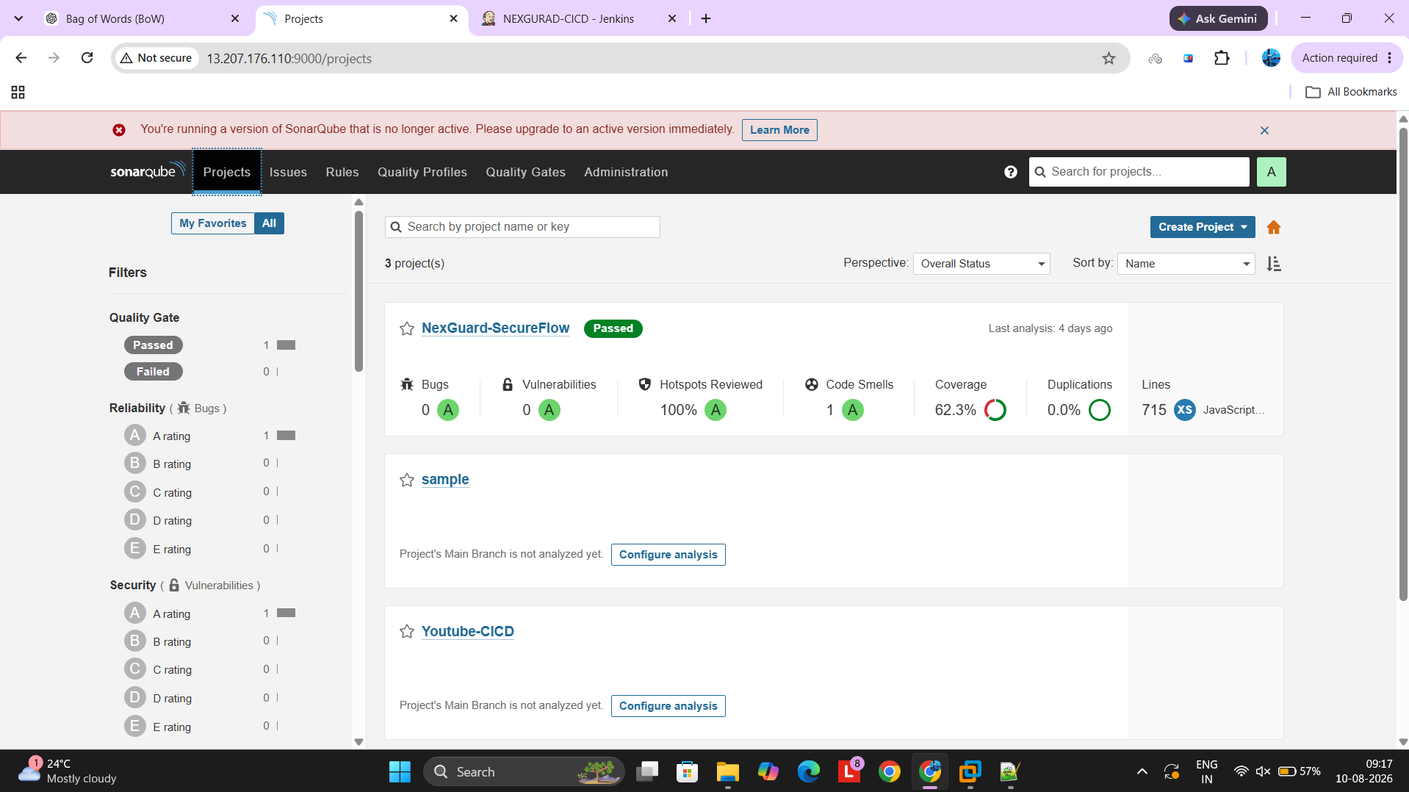
Figure 6: Final SonarQube project status and analysis metrics

9. Conclusion
SonarQube was successfully integrated with Jenkins for static application security and code quality analysis in the NexGuard-SecureFlow project. A Quality Gate was configured to enforce quality and security criteria, and the project was re-analyzed until the final result passed the Quality Gate. This integration helps identify code issues early and supports a more secure and maintainable CI/CD process.

10. Key Technologies Used
- SonarQube
- Jenkins
- SonarQube Scanner
- GitHub
- CI/CD Pipeline

